IN THE CIRCUIT COURT OF THE EIGHTEENTH JUDICIAL CIRCUIT
IN AND FOR BREVARD COUNTY, FLORIDA
CASE NUMBER 05-20_____-DR-_________________

IN RE:

Click or tap here to enter text.
Petitioner

and

Click or tap here to enter text.
Respondent

NOTICE OF VIRTUAL HEARING

TO: Click or tap here to enter text._(name of other party)

PLEASE TAKE NOTICE: A Virtual / Remote hearing has been scheduled in your case:

JUDGE: Honorable Kristen Smith-Rodriguez

DATE: Click or tap to enter a date.

TIME: Click or tap here to enter text. A.M. / P.M. (circle one)

TIME RESERVED: Click or tap here to enter text. Minutes / Hour(s) (circle one)

MOTION(S) TO BE HEARD:

Docket # Click or tap here to enter text. Date Filed:Click or tap to enter a date. Motion: Click or tap here to enter text.

Docket # Click or tap here to enter text. Date Filed:Click or tap to enter a date. Motion: Click or tap here to enter text.

LOCATION: Virtual Courtroom through Microsoft Teams. Clicking the link should take you directly to the Virtual Courtroom. Scanning the QR Code or typing the link into the browser may require you to download Microsoft Teams.

https://fl18.org/judgesmithrodriguez
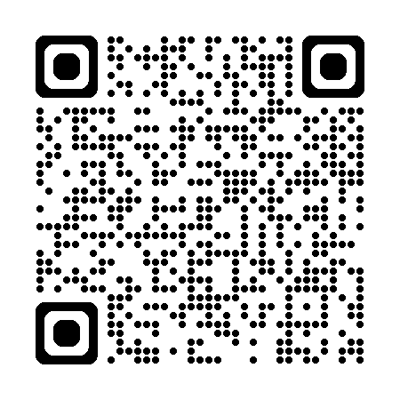
If you need assistance, please call the Judge’s assistant, Karen Flash at 321-264-6777.
EXHIBITS: For Virtual / Remote hearings, a printed copy of all exhibits must be delivered to the Judge’s office at Moore Justice Center, 2825 Judge Fran Jamieson Way, Viera, FL 32940 at least 2 business days before the hearing.

PLEASE GOVERN YOURSELF ACCORDINGLY. This includes having a stable internet connection, remaining in one location and not driving or walking, and dressing appropriately for court. Your video appearance is required.

CERTIFICATE OF SERVICE

I certify a copy of this Notice of Virtual Hearing was sent by ☐ e-mail ☐ mail to the person listed below on __________________________ (date).

Other party or his/her attorney:

Name: ________________________________
Address or Designated Email:
_______________________________________
_______________________________________

______________________________________
Signature of Party or Attorney
Printed Name: ___________________________
Address or Designated Email:
_______________________________________
_______________________________________

ATTN: PERSONS WITH DISABILITIES. If you are a person with a disability who needs any accommodation in order to participate in this proceeding, you are entitled, at no cost to you, to the provision of certain assistance. Please contact Court Administration at the Moore Justice Center, 2825 Judge Fran Jamieson Way, 3rd Floor, Viera, FL 32940-8006, (321) 633-2171 ext. 3, within two working days of your receipt of this notice. If you are hearing or voice impaired call 1-800-955-8771.

